**Sample Code Showing the implementation of State Pattern:**

**Wonderland(Client):**

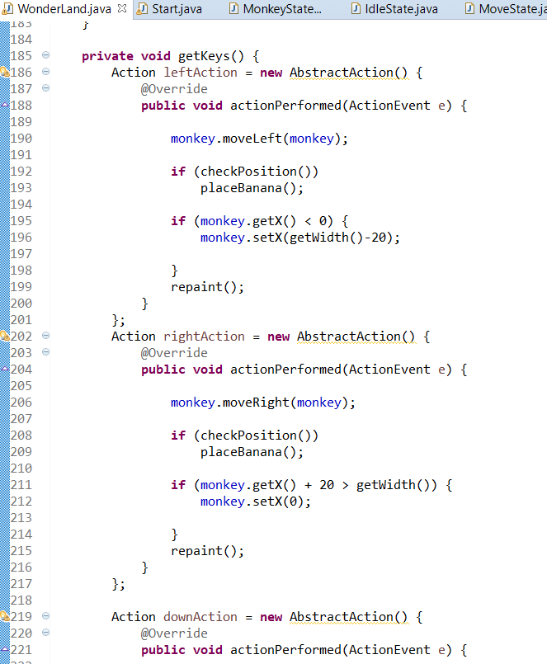

**Monkey(Subject):**

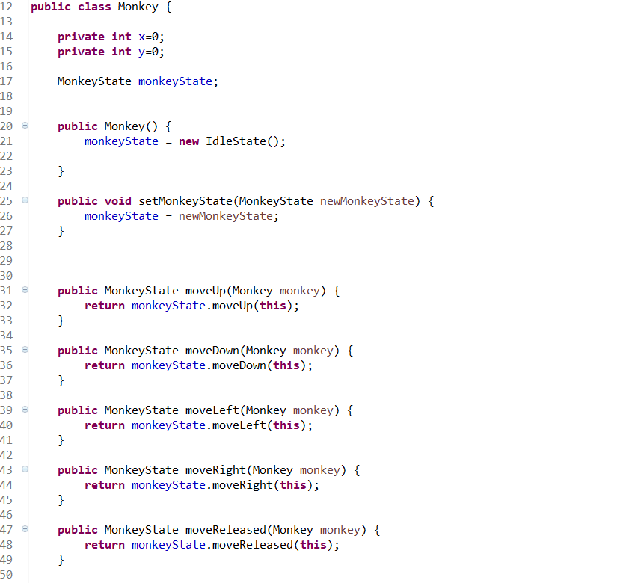

**Monkey State Class(State):**

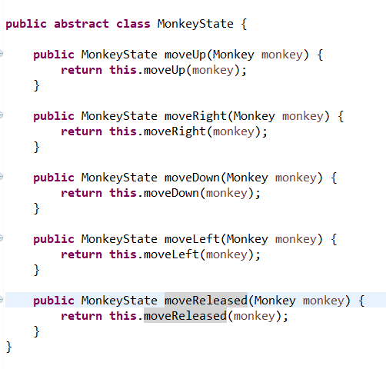

**IdleState(State 0):**

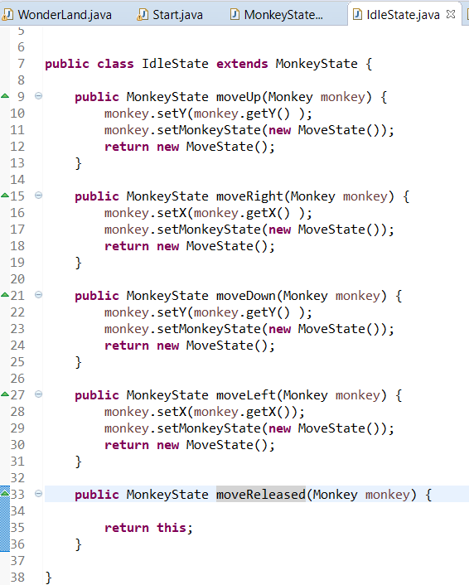

**MoveState(State 1):**

